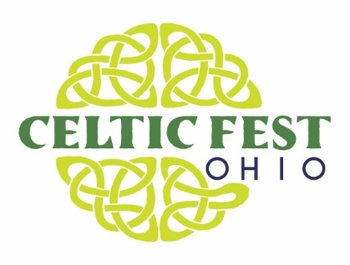
IF YOU’RE SUFFERING FROM CELTIC FEST OHIO WITHDRAWL SYMPTOMS. WE HAVE THE REMEDY!

MEDIA RELEASE
Contact: Jim Bucher, Media Coordinator
buchtvguy@gmail.com | 937-274-2882

Cheryl Bucholtz, Marketing Director
cheryl@brimstoneandfirellc.com | 937-402-1035

Well, if you’re like us at ‘Renaissance Park’ near Waynesville, OH, we all are suffering from ‘Celtic-fest-itus.’ There is no vaccination or magic pill, and we have a cure that doesn’t involve rolling up your sleeve.
‘Celtic Fest Ohio’ returns to Renaissance Park on June 19. Located at the home of the Ohio Renaissance Festival at 10542 State Route 73 in Waynesville the event features non-stop entertainment from 11am to 11pm. Its action packed, with music, food and fun all in one day. The largest event of its kind in the solar system. *Nasa has verified. (*Actually, this is an embellishment.)
It will surely cure what ‘ales’ you. And speaking of ale, we have plenty of frosty adult beverages from Guinness to numerous craft beers, Celtic concoctions and special tastings.
Entertainment you ask? How about Off Kilter, The Drowsy Lads, Father Son & Friends, Jameson’s Folly and more. There will be plenty of dancing featuring Dayton Scottish Dancing, Celtic Academy of Irish Dance, Cincinnati Highland Dance and Columbus Celtic Dancing, just to name a few.
Wonderful menu items to tantalize every tastebud such as gigantic turkey legs, chicken & chips, Celtic Baked Potato, Celtic Pizza, The Burger Shack featuring mouth watering burgers including a lamb burger and so much more.
And true, authentic Celtic dishes like Haggis, Meat Pie, Fish & Chips and of course Shepard’s Pie.
In addition, activities include Taste of the Isles small plate Celtic sampler, Whiskey Tasting, Miller Border Collies and the 42nd Royal Highland Regiment Encampment.
Whew, and that’s just the highlights! For a complete lineup of the day including music, food, schedule of events, and fun activities visit www.celticfestohio.com.
So, having the lock-down blues, come on out to ‘Celtic Fest Ohio’ for the cure!
Celtic Fest Ohio at Renaissance Park
10542 East State Route 73
Waynesville, OH 45068
(513) 897- 7000
Website: www.celticfestohio.com

MEDIA CONTACT:
Jim Bucher, Media Coordinator
buchtvguy@gmail.com | 937-274-2882

Cheryl Bucholtz, Marketing Director
cheryl@brimstoneandfirellc.com | 937-402-1035

