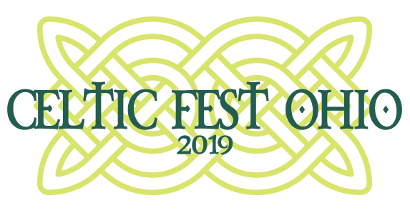 Contact Info:
Cheryl Bucholtz, Marketing Director
(937) 805-9322 | cheryl@brimstoneandfirellc.com

Jim Bucher, PR
(937) 274-2882 | buchtvguy@gmail.com

FOR IMMEDIATE RELEASE

EAT. DRINK. ROCK. AT CELTIC FEST OHIO

HARVEYSBURG, Ohio (May 16, 2019) – Celtic Fest Ohio returns to Renaissance Park, home of the Ohio Renaissance Festival, in June for another full weekend of Celtic celebration. Featuring 5 performance areas with over 20 acts and special events this year’s event promises to deliver an experience like no other.
Eat. Drink. Rock. at this year’s Celtic Fest Ohio with a line-up featuring a renowned list of traditional Celtic bands to Celtic Rock bands on two stages.
New this year! The ayes have it – Barleyjuice is a grand group of talented tunesmiths and prodigious performers, and the absolute best time you can have at a concert without removing your kilt. These five spirited yanks are currently one of the most beloved Celtic rock bands in the USA.
New this year! The Drowsy Lads thundered onto the Irish music scene in the US over 15 years ago and have become fan favorites at every turn. Sticking to traditional roots the Lads bring a fire and excitement that is quickly winning over audiences. The Lads are fond of creating their own spirited arrangements and offering occasional original compositions, even mixing in some bits of Bluegrass or Classical.
New this year! The Byrne Brothers are a Traditional Irish music and dancing family from Ireland. Their show combines explosive foot stomping Jigs & Reels with world class Irish Dancing and singing. The boys will have you in stitches all night long with stories and antics and in tears before the night is out with beautiful songs like Amazing Grace into a grand finale with Bagpipes and the three brothers dancing together.

-more-
A Celtic Fest Ohio favorite, Off Kilter returns bringing their high-energy Celtic Rock. The band is a unique blend of traditional Celtic tunes and songs with a rock twist, popular covers arranged with a Celtic rock feel, and original songs. The band recently ended an 18-year run as one of the most popular bands at Walt Disney World in Florida, and currently tours the country performing at many different venues.
Another favorite, Albannach, a tribal Scottish bagpipes and drums band, returns to the event. Founded in 2005, Albannach has taken the USA by storm. Their unique style, charismatic stage performance, and love for all things Scottish has drawn crowds from coast to coast. Albannach is known as a must see for the audiences young and old.
This year’s line-up also includes returning favorites Poor Man’s Gambit, Father Son & Friends, Jameson’s Folly, and Dulahan.
About Us
Eat. Drink. Rock. as Celtic Fest Ohio returns featuring 5 stages and over 20 acts and special events. Kick off the summer Celtic festival season with us at Renaissance Park. For more information, please visit www.celticfestohio.com.
Dates/Times:
Friday, June 14 – 6pm to 10pm
Saturday, June 15 – 12pm to 11pm
Sunday, June 16 – 10am to 6pm

Multimedia Links:
- Like Celtic Fest Ohio on Facebook to stay up to date on the latest news!
- Join the conversation by following Celtic Fest Ohio on Twitter @CelticFestOhio and by using the official event hashtag: #CelticFestOhio #cfo19
- Follow Celtic Fest Ohio on Instagram at @CelticFestOhio and share your favorite photos of the event by using the official event hashtag: #CelticFestOhio #cfo19
Referenced Links:
- Celtic Fest Ohio: www.celticfestohio.com
- Facebook: www.facebook.com/CelticFestOhio
- @CelticFestOhio: www.twitter.com/CelticFestOhio
- @CelticFestOhio: www.instagram.com/CelticFestOhio

###

