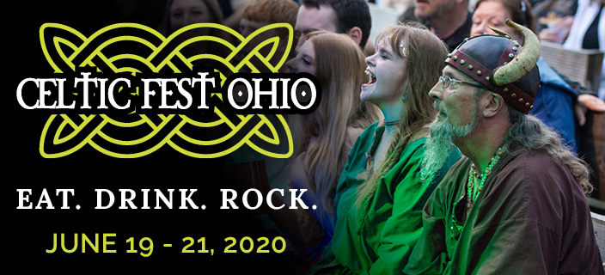
  - Shamrock Shenanigans Sponsor - $2,000
Align yourself and your brand as a sponsor and be a part of this growing Fathers’ Day Weekend tradition.

Your investment earns you:
- Exclusive event naming
- Your logo on the digital board at entrance
- Your logo in the event program
- Your logo on volunteer shirts
- 8 admission tickets each day
- 12 entries for event
- Display booth opportunity
- Logo/Name mention on event web page
- Mention in social media and event posts (2x)
- Logo on signage at each shenanigan
- Branded items for prizes

When: Friday, June 19 6pm – 10pm
Saturday, June 20 Noon – 11pm
Sunday, June 21 Noon – 6pm

Where: Renaissance Park
10542 East State Route 73
Waynesville, OH 45068

What: A one weekend celebration of all things Celtic. Experience music, dance, arts and crafts, foods,
beverages, traditions and heritages of the Celtic culture in a unique village setting.

www.celticfestohio.com

