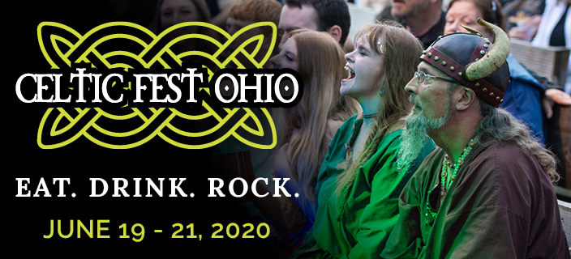
  - Stage Sponsor - $2,750
Align yourself and your brand as a sponsor and be a part of this growing Fathers’ Day Weekend tradition.

Your investment earns you:
- Exclusive stage naming
- On stage recognition at performances
- Your logo on the digital board at entrance
- Your logo in the event program
- Your logo on volunteer shirts
- 12 admission tickets each day
- Provide branded items for prizes and display booth opportunity
- Included in all media promoting the event

When: Friday, June 19 6pm – 10pm
Saturday, June 20 Noon – 11pm
Sunday, June 21 Noon – 6pm

Where: Renaissance Park
10542 East State Route 73
Waynesville, OH 45068

What: A one weekend celebration of all things Celtic. Experience music, dance, arts and crafts, foods,
beverages, traditions and heritages of the Celtic culture in a unique village setting.

www.celticfestohio.com

